Login

Register

In the first page of the website the options of login and register should be displayed.

(Details of log in found in page 2)

What happens when registration is clicked-

Customer Registration

Employee Registration

A webpage with these two options will be displayed.

When customer registration is clicked a form like the one shown below will be displayed-

When employee registration is clicked the same form will be produced with the added “Employee ID” option so employees can create their own unique ID.

LOGIN

When the login button is clicked two options will be shown –

Customer Login

Employee Login

When customer log in is clicked a form like the one shown below will be displayed-

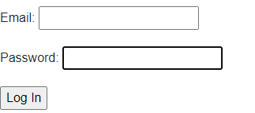

When log in is clicked through the customer log in a they will be redirected to a customer dedicated website.

When employee log in is clicked the same form will be produced with the added “Employee ID” option so employees can go to the website dedicated for them.